**Topics: Descriptive Statistics and Probability**

1. Look at the data given below. Plot the data, find the outliers and find out $μ, σ, σ^{2}$

|  |  |
| --- | --- |
| **Name of company** | **Measure X** |
| Allied Signal | 24.23% |
| Bankers Trust | 25.53% |
| General Mills | 25.41% |
| ITT Industries | 24.14% |
| J.P.Morgan & Co. | 29.62% |
| Lehman Brothers | 28.25% |
| Marriott | 25.81% |
| MCI | 24.39% |
| Merrill Lynch | 40.26% |
| Microsoft | 32.95% |
| Morgan Stanley | 91.36% |
| Sun Microsystems | 25.99% |
| Travelers | 39.42% |
| US Airways | 26.71% |
| Warner-Lambert | 35.00% |

A).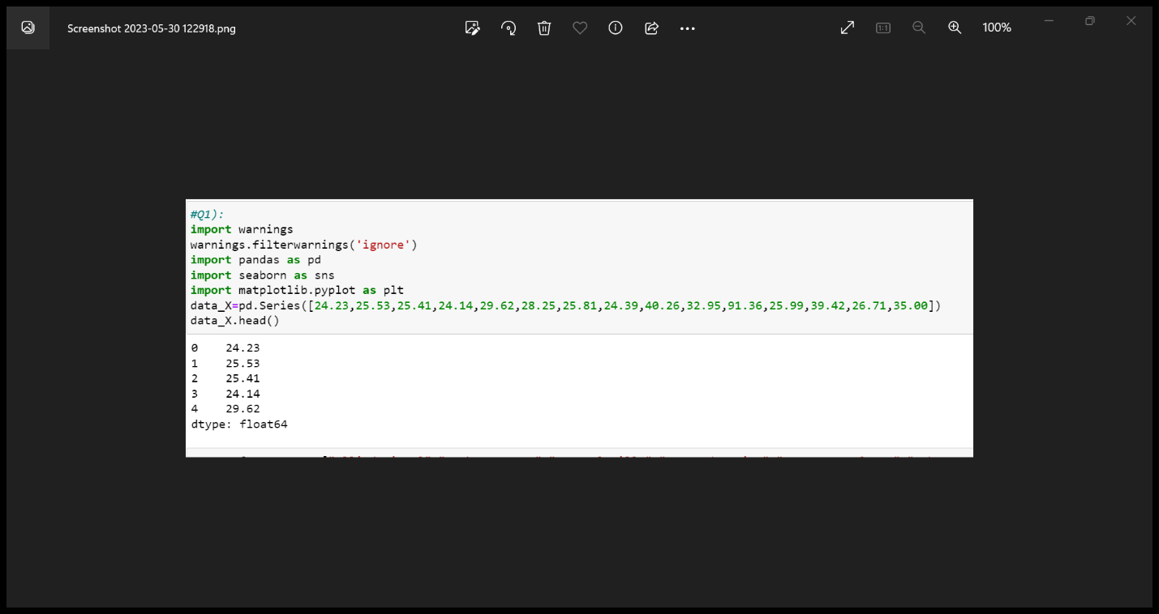

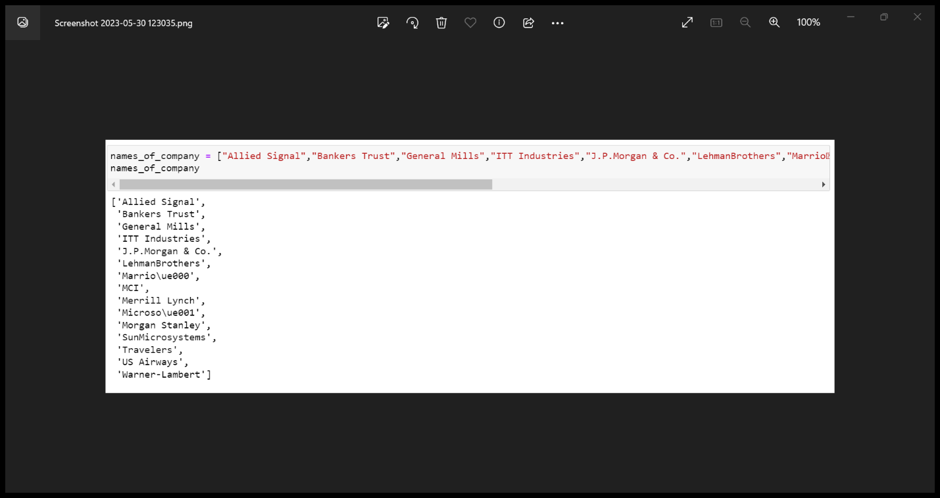

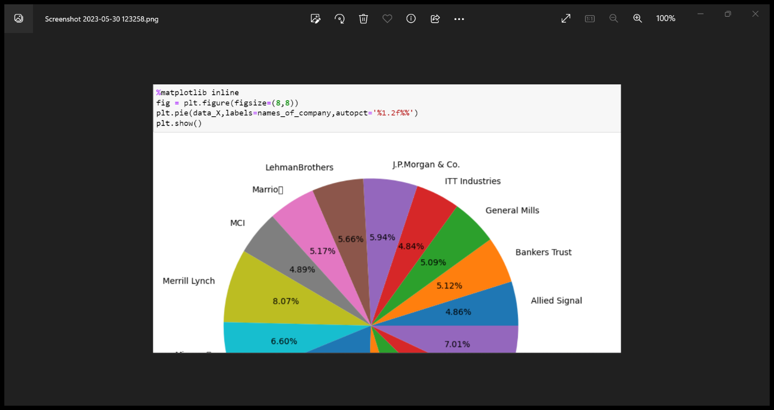

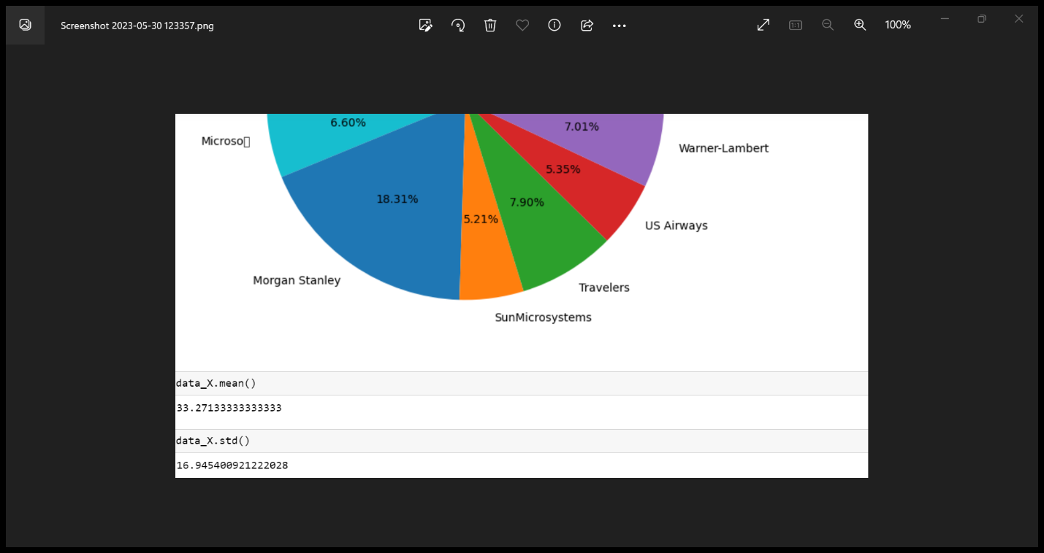

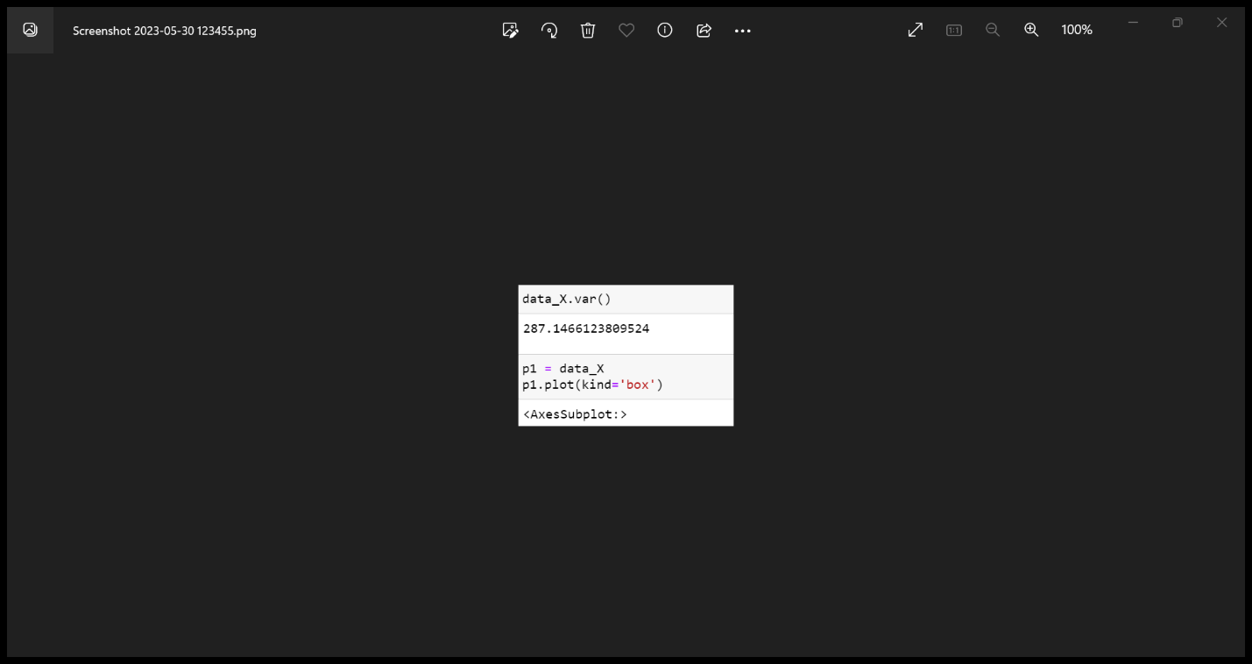

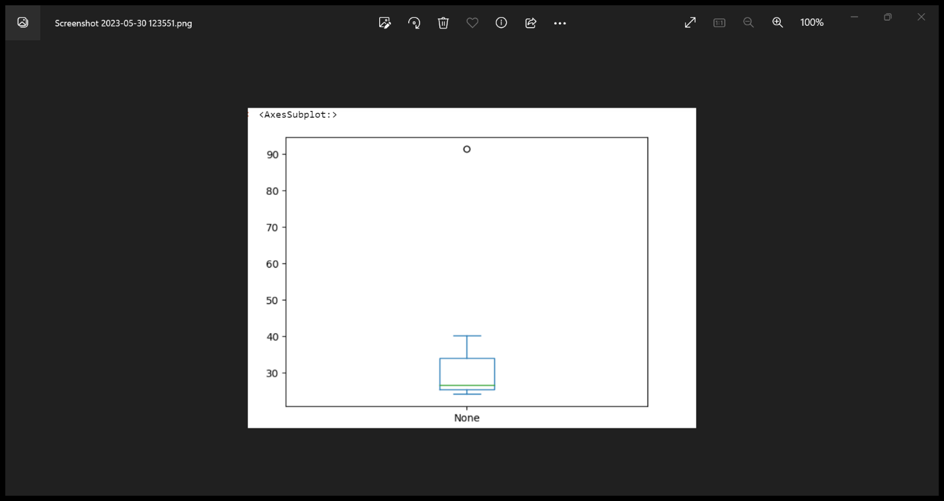

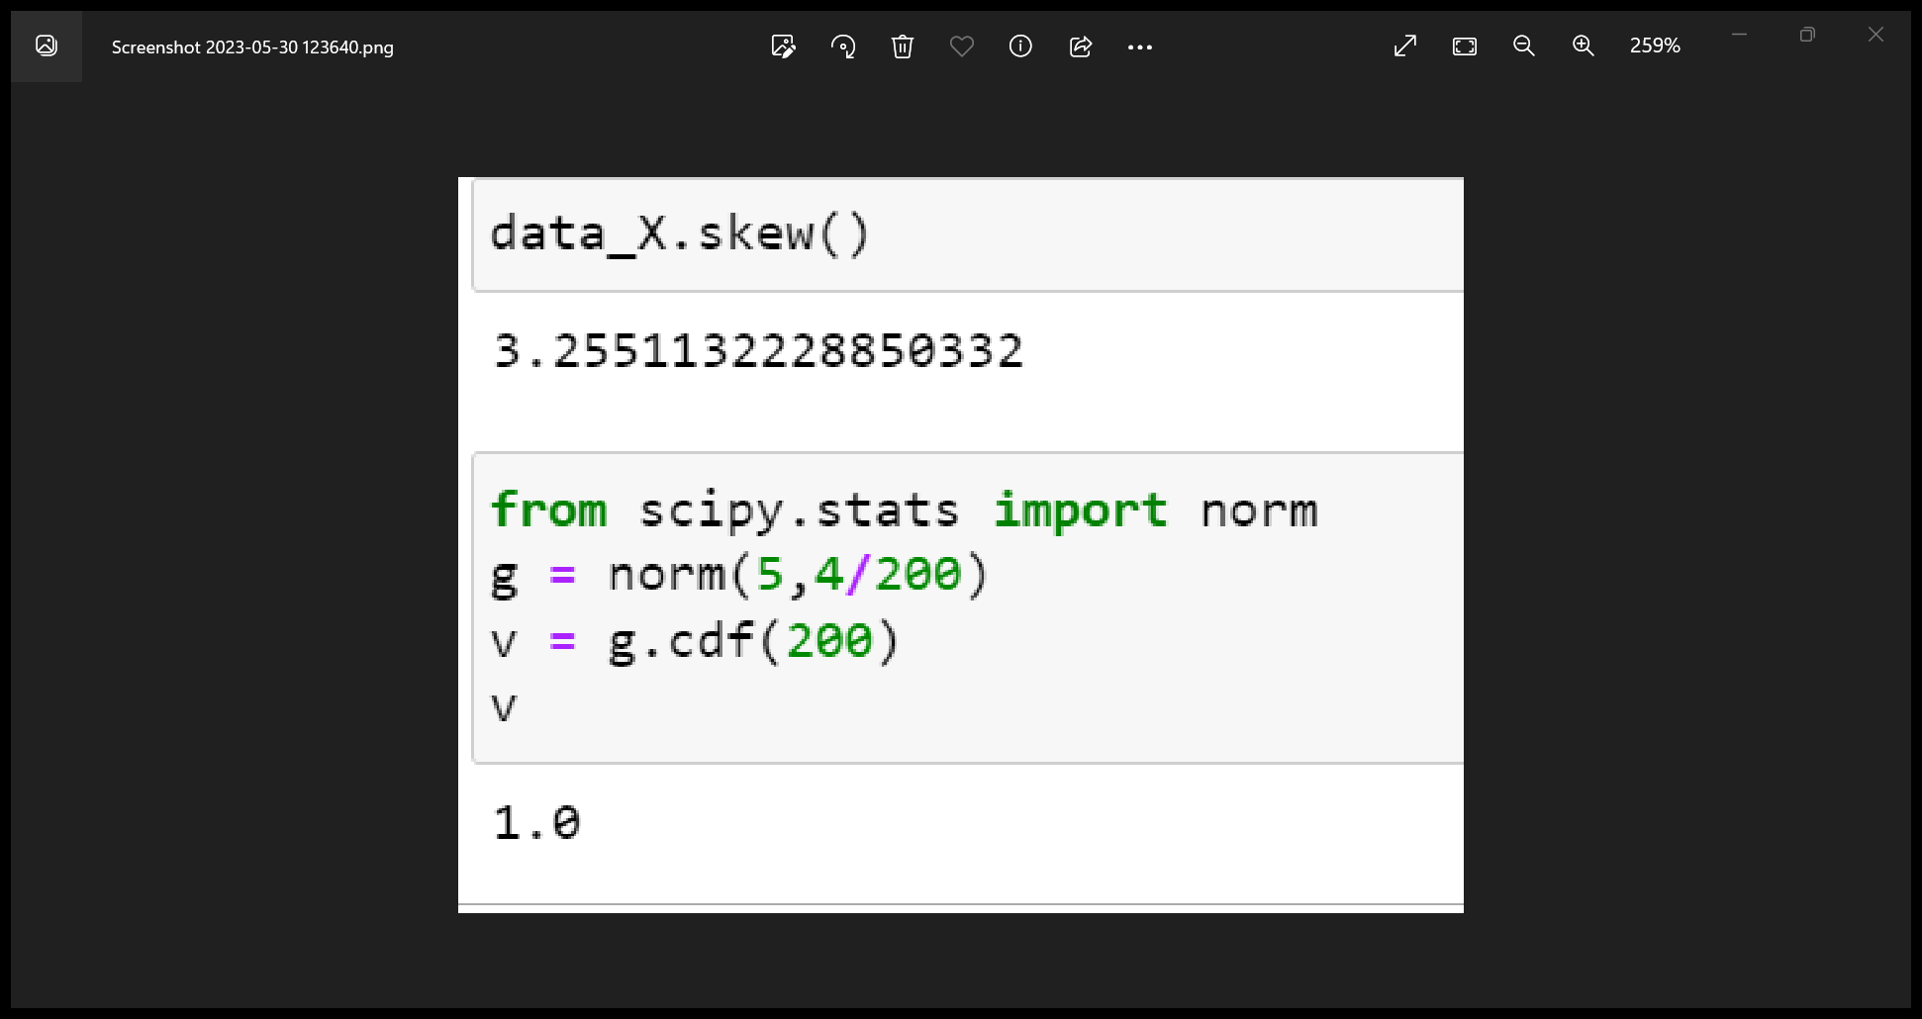



Answer the following three questions based on the box-plot above.

1. What is inter-quartile range of this dataset? (please approximate the numbers) In one line, explain what this value implies.

Ans). Inter-quartile range is defined as the difference of Q3 and Q1 where Q3 stands for 75th

Percentile and Q1 stands for 25th Percentile.

In the above plot, Q3 value is 12(approximately)and Q1 value is 5.

And IQR value is 12-5 = 7.

In other words, IQR is spread of the data.

1. What can we say about the skewness of this dataset?

Ans). In the above plot, the median is towards the left side and that indicates this dataset is

Positively skewed i.e,right-skewed.

1. If it was found that the data point with the value 25 is actually 2.5, how would the new box-plot be affected?

Ans). If it was actually 2.5, then there would be no outliers and the dataset will follow normal

Distribution.



Answer the following three questions based on the histogram above.

1. Where would the mode of this dataset lie?

Ans). The mode of the dataset lies in between 5 to 10(approximately 4 to 8).

1. Comment on the skewness of the dataset.

Ans). The above dataset indicates the positive skewness or right skewness whereas

Mean>median>mode.

1. Suppose that the above histogram and the box-plot in question 2 are plotted for the same dataset. Explain how these graphs complement each other in providing information about any dataset.

Ans). The above histogram and boxplot indicates right skewness (or) positive skewness and

Also contains outliers. Whereas, in the boxplot median is clearly visible and in histogram

Mode is clearly visible.

1. AT&T was running commercials in 1990 aimed at luring back customers who had switched to one of the other long-distance phone service providers. One such commercial shows a businessman trying to reach Phoenix and mistakenly getting Fiji, where a half-naked native on a beach responds incomprehensibly in Polynesian. When asked about this advertisement, AT&T admitted that the portrayed incident did not actually take place but added that this was an enactment of something that “could happen.” Suppose that one in 200 long-distance telephone calls is misdirected. What is the probability that at least one in five attempted telephone calls reaches the wrong number? (Assume independence of attempts.)

Ans). Here, if 1 in 200 calls is misdirected.

Then, probability of getting misdirected is 1/200.

Probability of not getting misdirected is 199/200.

Here, given n=5.

Then, the probability of that at least one in five attempted calls reaches the wrong number is

Calculated by P(x) = ⁿCₓ pˣ qⁿ⁻ˣ.

Where, n = 5,

P = 1/200,

Q = 199/200,

X = 1

P(x) = 5C1(1/200)^1(199/200)^5-1 #ncr = n!/r!(n-r)!

P(1) = 5C1(1/200)^1(199/200)^4

P(1) = 0.0245037

1. Returns on a certain business venture, to the nearest $1,000, are known to follow the following probability distribution

|  |  |
| --- | --- |
| x | P(x) |
| -2,000 | 0.1 |
| -1,000 | 0.1 |
| 0 | 0.2 |
| 1000 | 0.2 |
| 2000 | 0.3 |
| 3000 | 0.1 |

1. What is the most likely monetary outcome of the business venture?

Ans). The most likely monetary outcome of the business venture is 2000$ where the

Probability is 0.3 which is higher than the other probabilities.

1. Is the venture likely to be successful? Explain

Ans). Yes, this venture looks successful as by calculating the x more than 0 states that

p(0)+p(1000)+p(2000)+p(3000) = 0.2+0.2+0.3+0.1 = 0.8.

The probability of x gives 0.8 which states that there will be 80% chances of profit

In the venture.

1. What is the long-term average earning of business ventures of this kind? Explain

Ans). The long-term average earning of business ventures is (sum((x).P(x))).This gives

800$ where, the average earning of business venture will be +800$.

1. What is the good measure of the risk involved in a venture of this kind? Compute this measure

Ans). The good measure of the risk involved in a venture of this kind depends on the

Variability distribution. More variance more chances of risk.

Var(x) = E(x^2) - (E(x)^2)

Var(x) = 2800000 – 800^2

= 2160000.